Instructions to login into ThinSchool education portal

1. Type <https://ts.educateworkforce.com/> in your browser

**Note:** *If the URL of ThinSchool website shows* [*https://****courses****.educateworkforce.com/*](https://courses.educateworkforce.com/) *please change it to* [*https://****ts****.educateworkforce.com/*](https://ts.educateworkforce.com/)

1. Click on  (top right of page)
2. Enter your **Email**, and **Password**  
   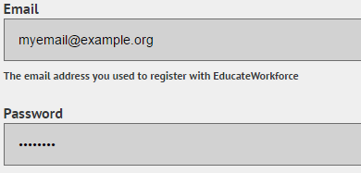
3. Click on 
4. On successful login, you should be able to see your course(s) under ‘Current Courses’

**Note:** *If you are facing trouble while logging in, or if you don’t see any courses under ‘Current Courses’, please inform instructor*

1. Click on  to navigate course home page.